Code4: Input from user
#include<stdio.h>
#include<stdlib.h>
int main()
{
int age;
printf("Enter your age :");
scanf("%d", &age);
printf("You are %d years old", age);
return 0;
}

Output:
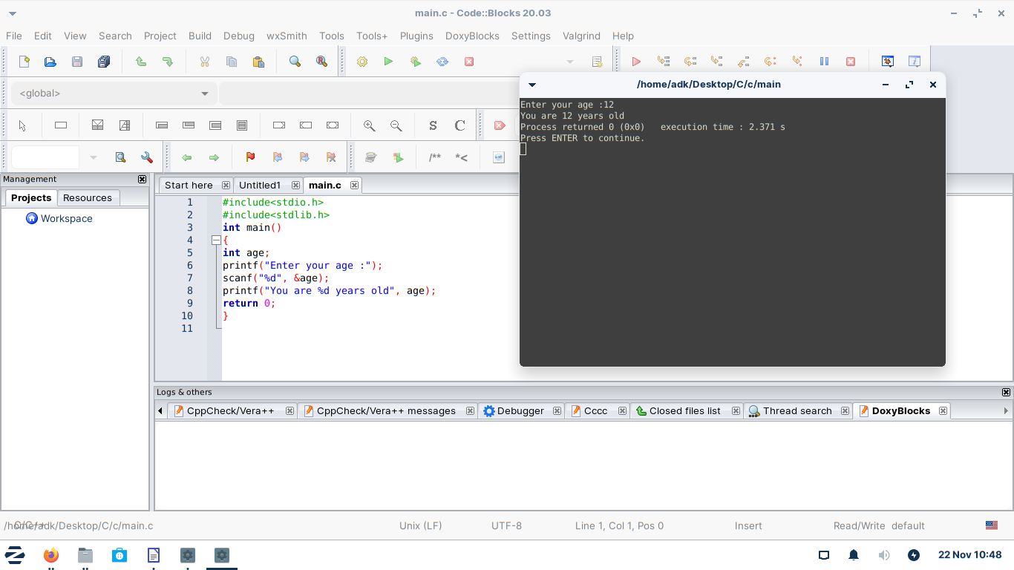

Code5: Basic addition Calculator
#include<stdio.h>
#include<stdlib.h>
int main()
{
int num1;
int num2;
printf("Enter first number:");
scanf("%d", &num1);
printf("Enter second number:");
scanf("%d", &num2);
printf("Answer : %d", num1 + num2);
return 0;
}

Output:
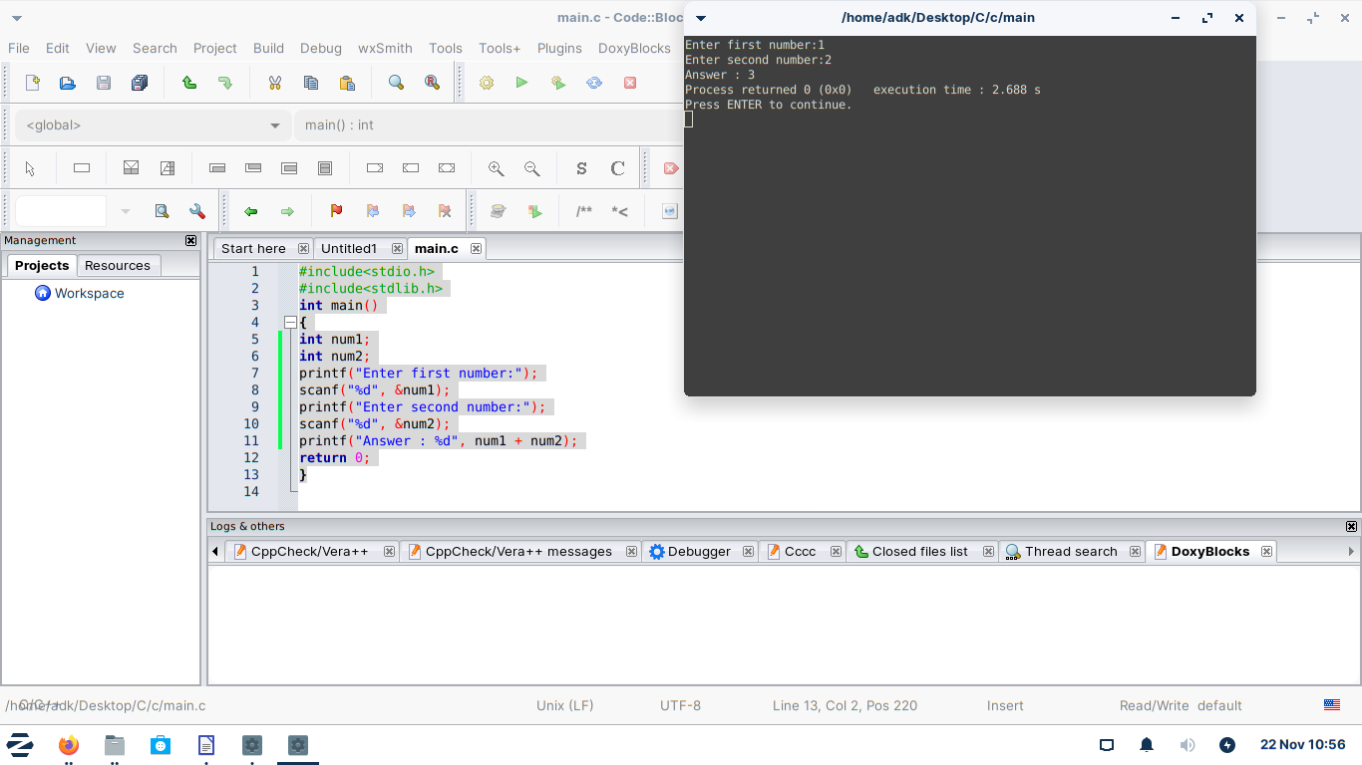

Code6: Building a mad libs game.
include<stdio.h>
#include<stdlib.h>
int main()
{
char color[20];
char pluralNoun[20];
char celebrity[20];

printf("Enter a color\n");
scanf("%s", color);
printf("Enter a pluralNoun\n");
scanf("%s", pluralNoun);
printf("Enter a Celebrity\n");
scanf("%s", celebrity);

printf("Roses are %s\n", color);
printf("%s are blue\n", pluralNoun);
printf("I love %s\n", celebrity);

}

Output:
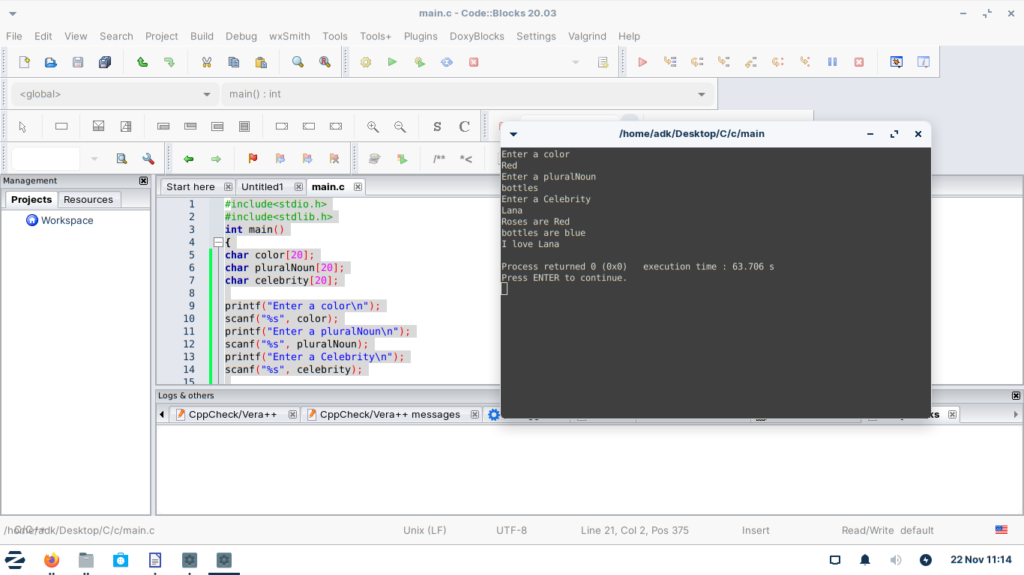

#include<stdio.h>
#include<stdlib.h>
int main()
{
sayHi("Mike\n");
sayHi("tom");
return 0;
}

void sayHi(char name[]){
printf("Hello %s", name);
}

Code7: Array.
#include<stdio.h>
#include<stdlib.h>
int main()
{
int luckyNumbers[] = {4, 8, 15, 16, 23, 42};
luckyNumbers[1] = 200;
printf("%d", luckyNumbers[1]);
return 0;
}

Output:
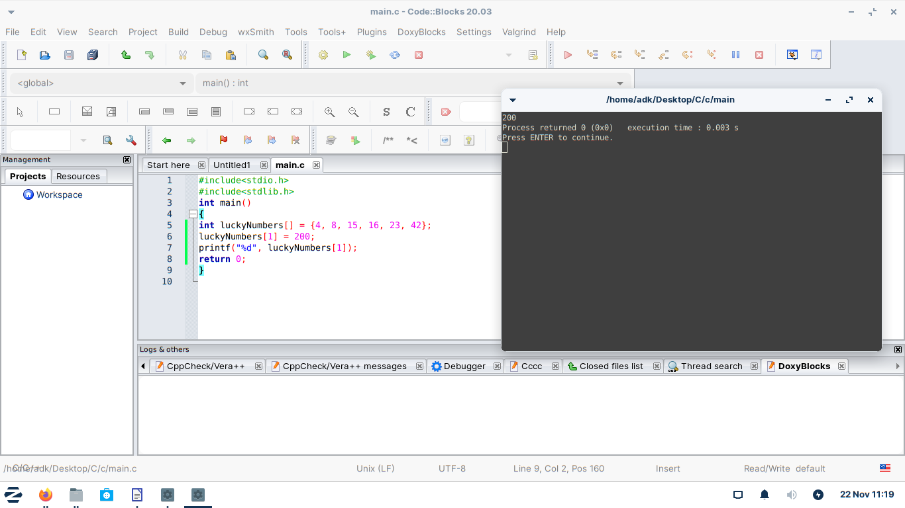

Code8: Functions

#include<stdio.h>
#include<stdlib.h>
int main()
{
sayHi("Mike\n");
sayHi("tom");
return 0;
}

void sayHi(char name[]){
printf("Hello %s", name);
}

